HOW TO CREATE A GITHUB ACCOUNT

1. OPEN GOOGLE CHROME AND SEARCH FOR GITHUB.COM

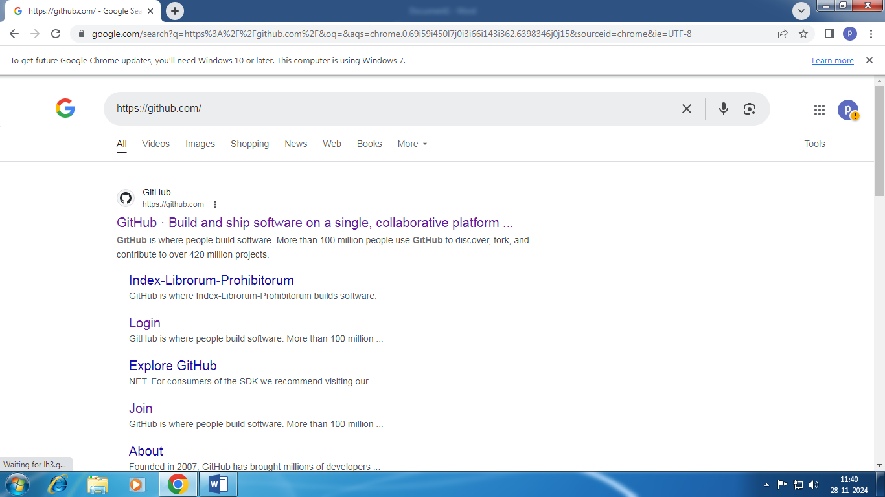

2.CLICK ON THE LINK



3.CLICK SIGN UP FOR GITHUB

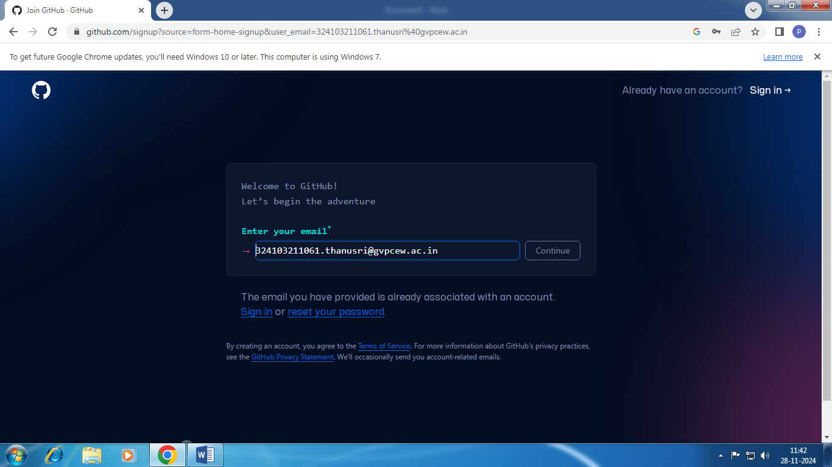

4.CLICK CONTINUE AND ENTER PASSWORD, USERNAME

5.VERIFY THE ACCOUNT

6. GITHUB ACCOUNT IS CREATED

